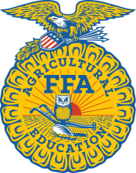 Bill Stoltze Scholarship

$1500 Scholarship for FFA members furthering their education

Personal Information
(Please Type or Print Neatly)
Name (last, first, middle):
Permanent Mailing Address:
City, State, Zip Code:
Cell Phone Number:
e-mail address:
Parent/Guardian Name:
Mailing Address:
Home Phone:

Educational Background
High School Attended:
High School Address:
Proposed College/University:
College/University Address:
Proposed Major:

CERTIFICATION
I certify that all information provided is true and correct. I understand that any false answers or deliberate omissions in this application may be grounds for rejection and withdrawal of the award.
_______________________________________
Applicant’s Signature Date

Applications must be complete and postmarked by April 10, 2019 to be considered.
Please send application to Alaska FFA Association 1509 South Georgeson Rd. Palmer, AK 99645

Please answer the following three questions. Please use no more than two additional pages.

Why have you made the decision to further your education past high school?

Explain your supervised agricultural experience project and what you have learned from it?

How has the FFA organization helped you develop as a leader?

